These results are from the report downloaded on September 3rd.

## What are the most common settings where you use one of the translation tools?

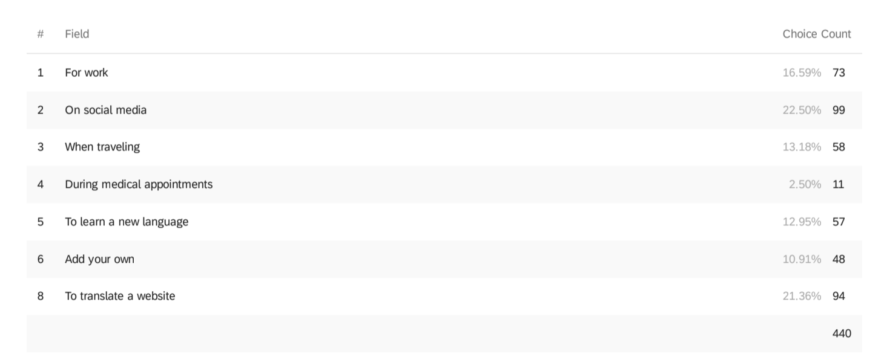

To use the right term when educating my child

To translate song lyrics

just for fun

speaking to multilingual friends

At home

Government information; bills; children’s school updates

helping kid with foreign language class

Writing

At home when talking to parents

To teach

abulary when talking to native speakers to aid my voc

For child learning a new language

to translate formal words or phrases within the context of leisurely reading

When watching tv

For communication on daily basis

When I see a new word or a phrase.

Translate parents

Crossword

in books

Curiosity

To do Shopping

When listening to music where I do not understand the lyrics

Curiosity

curiosity

To learn a language better

Text on social media

Mostly just day to day life. it’s a multilingual world

browsing many websites at once

Scientific paper

Family

when watching TV

organizing with neighbors

Historical research

To look up the correct spelling in a language I am verbally fluent in, but which uses a different alphabet (one I can read/write but make frequent

spelling mistakes in)

Family situations — I speak my in-laws language as a second language

To read a news story (whether formal journalism or informal online posting)

Ordering food

I live in in a city where there are two official languages so switch between those I often use translation tools

reading

Reading a book that has a foreign phrase.

for recipes

Philosophy (e.g. Charles Taylor's _Ethics of Authenticity_), literature (Salter's _A sport and a Pastime_)

To gain new vocabulary in a second language

Learning domain specific terms

Family

For studying

translate phrases on the internet, from websites etc

Reading novels

## How do you figure out whether a translation is correct or not?

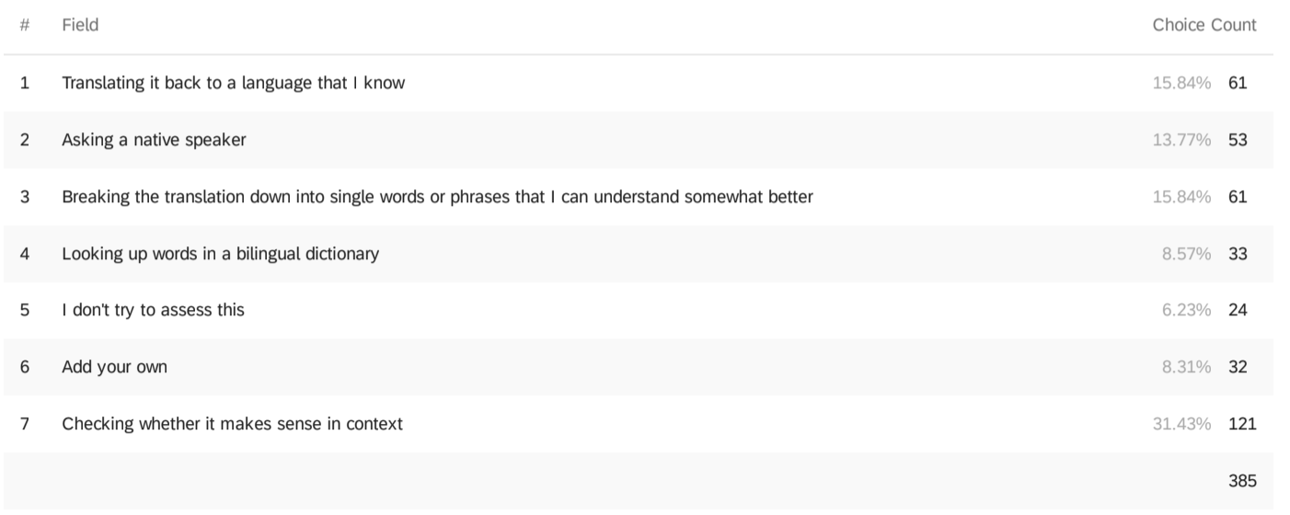

Usually if I'm using an automatic translation tool it's for a language I have some familiarity with but am not fluent in; so I assess based on what I do know

Googling the result to see it used in context, in the foreign language

Search a selection of the phrase; look it up on Wikipedia and change the language

Sometimes I ask someone with some ability to speak the target language.

Look for definitions of the words appearing in the translation in their own language

Many times I know enough of the language

perform web searches on the translated text to determine context; using other automated translation tools as a check; translating word by word

There's no 'correct' just if it sounds like it fits well enough.

Reading the definition of the translation on a monolingual dictionary or if not possible, its wikipedia page

Use my own (rough) knowledge of the language to assess the translation

I really struggle validating correct conjugations and natural sounding grammar using translate. For validation, I'll do additional research to see if I can find any articles on the topic.

When the English version is not very natural, I'm more suspicious

Because I usually translate to my native language, I am able to tell whether the translation makes sense.

Analyzing the grammar!

In personal contexts/social media, I don’t assess this; in professional contexts, ask a native speaker.

Sometimes I have existing knowledge of the language that helps me assess on my own

compare with another translation tool

I often know enough of the foreign language to be able to tell if the translation is completely off

In some situations like community outreach, I pay native speakers to translate

Trying my new vocabulary on native speakers

Search for examples online, search for synonyms

Confirming the semantic correctness (e.g., following directions and confirming I arrive where I need to be)

googling it and looking at how it is used

Google to look up discussions on sites like WordReference and make sure that it doesn't have a double meaning that makes it inappropriate

(slangy, sexual, etc.). Sometimes I change the tense if it's in Spanish, which I know fairly well (Google Translate does better at translating simple tenses)

I only translate languages that I have a scanty knowledge of, so I check it to my knowledge. Sometimes I look up cases or tenses in greek or latin

Seeing if the translation of unknown text makes sense in its context

Usually know it sucks if English doesn't make sense or doesn't match accompanying visuals

Conformity to context

Look up the description of the word on Wikipedia

Looking at the context to see if it makes sense

## Which of the following problems have you encountered?

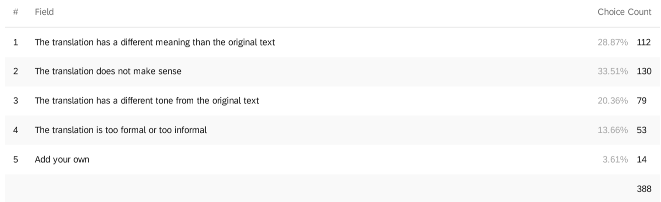

## 

## If you would like to add a problem you have encountered or expand on the problems you have encountered, please do so here.

The words who have different meaning should be taking into account i think this makes improvement in the translation process

My favorite-ever example of Google Translate gone wrong: I lived in South Korea for a while and spoke/read only limited Korean. When Google

Translate-ing directions on a package of pancake mix, what came out included the phrase "Spongebob Squarepants".

Most of the time, whenever I tried to use translation tools the main problem is translating domain-specific jargon terms.

Translation into words that don’t make sense in the context but are probably correct word to word translations

It is the ‘lemon sole’ problem. There is not enough context for Google translate to know that I don’t mean sole of my foot. This occurs from English at least to the three languages I speak (I haven’t tried more)

Translation of vaccines and medical terms would be nice.

Poor support and low translation quality for regional Indian languages (Bengali, Tamil, etc). These languages are not low resource - Bengali has ~95 million native speakers in India alone, but I'm unsure if translation models have been built for/evaluated on these language pairs.

sometimes translation is not word for word

usually long paragraphs are hopeless to translate

Typically the automatic translators do a poor job of adding context to the translations I’m trying to enter. That’s why I would need to either double check with a native speaker or another source (such as a text book or language specific web site) just to make sure.

If the source text uses formulaic technical language, abbreviations, or less-common idioms, the automatic translation often fails.

Translation provides only one translation but perhaps providing multiple different interpretations will be more helpful

On Google Translate, I like the newer ability to look at alternate suggestions and the ability to make the suggestions yourself...but this latter ability I rarely feel confident enough to use...in some sense who using this could ever have that confidence (and be right) because they're

translating because they're not sure of the meaning.

automatic translation tools are usually pretty bad with gendered languages like German, because by default all the articles on gendered terms (like cook, etc) are male. Or the articles for typical things like "food" are not mentioned unless you query with the article in the original language (ie. searching "the food"). ALSO in languages like German with irregular plurals translators never seem to mention these things as worth learning even though they, like the irregular gendered German articles, are important to learn

Even for translating individual words, Google Translate can have some pretty weird behaviors, like in Romanian it sometimes generates with diacritics and sometimes without (presumably because it was trained on both kinds of data). When translating from English to other languages, it can be hard to get it to understand when there should be distinctions that don't exist in English, like different pronouns for levels of formality, 2nd person plural. Sort of a separate issue from the translation itself, but Google Translate's speech to text isn't great with homophones even when they should be disambiguated by pronunciation. Like if you transcribe "Tā shì wǒde māmā" in Chinese, it'll choose the male 他 even though contexts where that makes sense are rare.

I've found that Google translations may be correct when phrases or parts of sentences (specifically ssubject + verb) are entered but change to entirely different, incorrect translations once a full sentence is entered. To account for this found entering partial sentences or single words can be more informative and/or accurate. Furthermore, those formerly correct translations are not provided as alternatives. Translations from Google and Microsoft frequently differ and have little in common. For the use of translating formal and poetic phrases both are often incorrect but Microsoft does a better job for this purpose. Of course, languages such as Spanish and French clearly provide better translations than less common ones. I would recommend the use of a translation/dictionary for a new learner, not the use of automated translation for new learners--particularly for learning Persian.

The robots doesn't understand the Russian slang words in use - I believe they sometimes are context dependent (created in the moment)

My biggest challenge is assessing the quality of the translation, especially when going from English to the foreign language (I'm native English

speaker)

Usually can't translate commonly adjoint words ex. cheesecake, honeybeer

Translations are often very different from what native speakers tell me. Sometimes they're completely wrong. Other times they're phrased in ways that sounds terrible to a native speaker or even someone who knows a little about the language like I do.

Translating from English to Albanian results in poorer text quality than translating to, say, Turkish. I would really appreciate if languages that are used by relatively smaller number of people (e.g. Albanian) are considered important enough for improving their translation quality.

I know the translation depends upon the source we put in but sometimes just reading out the translated sentence means, there was a issue in source. So of the translator could give autocorrect options it would help making sense incase the source text is messy or grammatical incorrect

They are many errors I have faced before such as given wrong meaning when translated to my own language. Plus, skipping some sentences or replacing the order of the sentences which changes the meaning. Also, many grammar mistakes specifically prepositions which give weird

meaning, or funny sometimes!

I wish we could translate when they are speaking.

Particular regional idioms and specific terminology

Better representative words for other languages in a particular language such a way that it communicates the emotion and tone behind the words should be considered.

Instagram automatic translations in particular often seem to just skip large chunks of the text and the result is nonsensical. Copying the text into Google often gives a slightly better result, but it is a tedious process. I specifically encounter this problem frequently from Hungarian to

English, as well as Scottish Gaelic to English (the latter usually recognizes that it needs translation, but gives the original text as the result).

Sometimes the translations are ungrammatical. For example, a tweet translated into english may have ungrammatical structures or unlikely

word choices

Translations between a pair of languages that does not include English are often of poorer quality

errors of proper vs common nouns (a brand versus a common word)

I would like to translate all non-english text on my screen even while navigating through different apps

Perhaps by lack of representation in the corpus, most translations of casual text can't pick up alternate or more casual meanings for words. I also encounter problems when the input language has honorifics or respectful markers that the target language does not have.

The main problems are with translating short phrases. Given the ambiguity of language and the lack of context, automatic translation doesn't have a chance. Highly informal language on social media also often goes wrong (possibly made worse by typos in the original).

Generally, I use Google translate as a means of figuring out the precise word or conjugation that I mean. As in, I'll have like the general structure of what I want to say. But the problem is that Google translate is meant to go from English -> Spanish, and not from (Broken Spanish)

-> (what I meant in Spanish).

vous instead of tu

Frequently tweets and advertising signage in high-educational-attainment countries mix multiple languages in ways that are very informal (and thus not covered in common parallel-text corpora) and may rely on country- or domain-specific knowledge that Google Translate lacks (e.g. that

a noun is a brand name).

The most common problem I face is in honorifics being inaccurately translated when using languages where they are critical. To counter this I’ll often look up terms directly as well or check with experts.

I translate Korean to English and the grammar differences make translations clunky. But the biggest problem is translating nouns and specific words. Often these are mistranslated because the translation engine doesn't have the ability to understand them.

Hungarian translation is often quite bad.

There was no word in the other language (e.g. fairness can’t be translated)

Facebook translation is especially problematic — my family sometimes uses it to figure out what I am saying with my in-laws and the accuracy is terrible (this has led to one fight!)

It's particularly bad when a "breaking news on Twitter" event meets "somebody's amateur automated translation". So some user in Turkey or Pakistan or Lebanon posts an update about an earthquake or an explosion or something dramatic, and then a bunch of US-based English

speakers run the text through an automatic translation and run with whatever it says -- even if they have no idea whether is right. In particular I notice that US English speakers are often confused about Urdu vs. Arabic. You have to be very careful and responsible but people often don't know what they don't know (Dunning-Kreuger effect) and that makes for some very messy and sometimes dangerous translation errors. (And even interpretation, when we start talking about online video clips.)

One example would be when translating some text in Moroccan dialect written in Arabic, the automated tools treat the words as standard Arabic words and often the translation doesn't make any sense.

Image to text translation is needed in countries which don’t have english as language for their official and government communications and we have to ask friends to translate letters. No proper scanning tool which does it effectively yet

Translation only good for the most simple sentences. Students adjust writing to fit translator, which hides their intelligence.

Hebrew without vowel markings getting translated into english works worse than hebrew with vowel markings

It's become pretty good recently for english to most european language. I'm a fairly proficient speaker in 5 languages, and it's really helped with developing my vocabulary. Sometimes it's wrong for domain specific terms, but then you can use wikipedia and switch between languages, search for a domain-specific website...

Speaking with people in my city, I sometime use translation tools in advance, to try to learn things to say in preparation for a meeting or encounter with a casual acquaintance. I also study in advance to talk to workers who don't speak English, but the translate tools are not super

helpful. They don't help you speak or communicate better.

Can't think of the exact wording, but when translating the websites of european researchers, I often find the navigation menu text doesn't translate into what I think the english equivalent would be (But is close enough that I can usually make sense of it)

When translating languages for work, accuracy is key so most of the time I double check with a colleague who speaks that language, if one is available

I only saw this when translating from a language I know (either on Facebook or a website that was translated and I was curious to see). -- Innappropriate translations which are bizzare. E.g. my name is Timnit and it got translated to Habibi. Timnit is also a word in arabic but the

website was in Amharic. Amharic is a semetic language that has a lot of similarities with arabic but I'm very confused how timnit got translated

to habibi. Timnit means wish, and habibi means my love in arabic. --Sometimes sentences that make no sense so its clear that the translation

isn't working

## Think of a recent time when you needed to translate something. What was the situation?

I wanted to know how to translate a particular phrase.

Reading online news in German

Translate a flower’s name

My parents used a phrase in hebrew I didn't understand, and they didn't know how to translate it

Needed a colleague to understand content in a language that I did understand, but didn't have time to transcribe.

I found hard English words to understand them!

I was reading a post on a forum

Read a news article

Today, I was translating a document for work and wasn’t sure about a certain technical term.

needed to share a dpum

I was translating an app

Translating a specific, complicated phrase from English to my second language

Evaluation of translation model

Needed to understand some instructions

Needed Japanese-English translation on some instructions for assembling some furniture I had ordered online.

a documentation of a software written in another language

At work

a tweet in Farsi from a journalist in Iran

read Japanese Tweets

I was talking to my grandma and I needed to say the word "eyebrow" in Vietnamese to my grandma.

i had to send an email in english, since it's not my native language I wanted to make sure it was saying what I wanted to say.

Helping translate a library card application into Portuguese (I am fluent in Spanish, we had no Portuguese speakers available)

I was trying to write an article using local language and I needed to incorporate external works. Then I needed a translation and jump into

google translate to do that.

I was watching a foreign language show (movie or YouTube(

I wanted to know what something said written in Cyrillic but in Farsi

A tweet in a different language

A news article relating to a fire popped up on my phone.

Explanation

I needed to translate documents for immunization records.

Wanted to know what a common Indian spice is called in English

chatting

Translating a text message to Spanish.

Filling out a form,

looking up a slang term in spanish

Translating a research article

Language learning

I was recounting things my parents said.

I was writing a report and I couldn't remember the word I wanted

Song Lyrics

A tweet in another language

I was having a conversation with someone

I was watching a show in Spanish with Spain dialect. I didn’t understand their slang so I had to look it up.

I had received a test report for Chinese-made PPE.

My French friend told me about a French film title

I was at a supermarket

I get a lot of tweets in foreign languages. and whether I have experience in the language I want to be sure what they are saying.

I generally need translations of technical terms. Moreover, I need catalan to english translations more or less as often as english to catalan, I learn the terms from courses and speaking to colleagues, situationa which continuously happen in both languages.

I'm talking to my German relative and I wanted to check if my German was ok.

needed the name of a fruit from spanish to hindi because my daughter (3 years old) asked (she is learning 3 languages, her dad and i know 2 each)

Adding a flourish to a business email

I am taking a language course

Needed translation of a news source

I learn languages as a hobby, and it's sometimes difficult to find the relevant base word by search in a dictionary if it's been conjugated,

inflected, etc.

AP Chinese class; I had some concepts in English that I needed translated in Chinese (no academic dishonesty, though), with those concepts

being daily-life-oriented (food, Chinese society, Chinese cultural standards)

Specific words like "mask" and "social distancing" regarding covid and family safety

I've been practicing my French recently. I've been trying to read Le Monde on occasion, and starting French conversations.

I was reading a book in Persian and was not familiar with some of the words I encountered.

Watching a tv show and trying to understand slang

Friends in Belarus posting on Facebook about their activities

Reading a tweet on twitter

Shopping

A news article

Translate a tweet part of which was spelled in a different language

I was trying to read a german webpage (I live in a German-speaking country and don't speak the language)

I had to write a short summary of my work in my native language.

I used to speak to my maid. She is a Malaysian and hence speaks malay. And I converse in english

I keep up with a band who is Korean and I translate back and forth between their content

Helping with my brother's Spanish homework

Few hours ago to translate this word "silhouette".

Quickly internationalizing some code

My boyfriend speaks only Hebrew with his parents, and that includes IMs. When he is tired and she IMs him he sometimes lets me copy paste

it into Google Translate to see how well it did.

Knowing the names of Chinese food ingredients and medicines in English and vice versa

while doing crossword

Learning a new language.

i was watching a movie and someone said something in another language but the subtitles just said [speaking different language] lol

Two characters in a book were speaking in their first language, Portuguese, and it wasn’t translated. Even though it probably wasn’t going to be

necessary to have understood it, I still wanted to know what was said. So I looked it up.

Shopping

Translate a Spanish quote from TV to English

I was reading a text in a language I am learning and I needed to look up a word.

Wanted to understand song lyrics

Reading a book written in both English and Spanish

I was in Japan for a school project. While we had a whole crash course in Japanese, it wasn't enough to allow me to read or speak the

language. I often used Google translate to ask for certain directions or ask about a product

Getting specific niche advice for my profession

I was writing an email in a language I'm still learning, and wasn't sure about a particular word

Translating something my coworker said (I'm trying to learn Spanish)

wanted to look up a type of bird because it has a similar name to another kind of bird in my language, but I only knew the name of one of the

birds in English

Needed to translate a tweet

Reading a novel in Spanish on an iPad app

Private situation

Academic text

Understanding some text in a language that I cannot read

I wanted to understand an Instagram comment in another language

Needed to translate an acceptance letter into portuguese, for university bureaucracy

I was teaching myself korean and translated a korean sentence I heard into Japanese.

An English phrase that was based off of a French phrase I had trouble remembering

I'm learning Spanish. I wasn't sure how to say something, so I wanted to see a translation.

reading a tweet in German

reading a link fro a tweet about Asian issues

Was reading a Bangla article and I didn't know the word.

Translating a form I got from my physician.

Too tired to process Japanese

on my screen

Look up certain word

Foreign news website

Converse with an old Chinese woman about Tai Chi

Translate tweets from artists I follow

Speaking to a friend whose native language isn't the same as mine

Tweets in Hindi. Translated to English.

twitter

Needed to translate an article from English to Spanish

Reading news about an event in another country

Tweet from a European scientist in Spanish on a topic of interest to me.

Japanese music event

An e-mail chain which was half in a foreign language.

I translated an article in Russian about the payload of a satellite launched earlier this year that was not covered by western press

A Wikipedia page was only available in Vietnamese: the person had endorsed a politician and I wanted to know who they are (a S. Vietnamese

General that escaped to California)

News from Poland election

Reading social media in a foreign language I know but have a weaker/atrophied vocabulary in

Working with a foreign consulate whose webpage is all in another language

Reading a book in a second language and encountered a word that I did not know.

Trying to sell something on FB, and a prospective buyer replied in Spanish.

Trying to translate the same nuanced meaning from my language to English when telling a story

personal text

translating tweets in persian and japanese

Farsi is my second language, and on twitter I sometimes have to use translate to understand the meanings of certain words or phrases if the

tweet is in farsi.

I saw a poster in a TV news broadcast and wanted to know what it said.

Translated technical terms in a research paper

Looking up a less common Korean phrase my wife used.

communicating with my tenant association

Text from a news report associated with my research

I needed to look up some German, which I am learning but not yet good at, to send in a text message

a russian tweet

In Lyon, a man at a closed bus stop was trying to give me alternative directions to my hotel. He did not speak English.

I've needed to translate websites for work.

I was writing an email.

I was listening to a song in Italian (a language I am learning) and wanted to look up a word I didn't undertand

My mother in law told me about a tea I had never heard of (she is a Portuguese speaker, Portuguese is my second language) and I didn’t know

what it was

I wanted to send a tweet in Spanish

Translating an email

reading a blog in another language

I got an email in a language I didn't speak.

in my browser reading pdf book.

Ordering food

To translate a reference made in another language (Spanish)

email translation, menu translation

Needed to translate a news article in German to English.

an essay in french

Reading a paper related to my field and I wanted to see translation for a word to make it more tangible

Saw a tweet in hebrew

I couldn't express in english a thought in french and searched for various alternative expressions

Reading a foreign phrase.

I encountered a phrase on social media in my second language (French) that I didn't recognize.

Teaching abstract computer science concepts in English with students' learning English

I needed the farsi name for an ingredient in a recipe

## In that situation when you needed translation, what did you do? (I’m deleting the responses that are just MT)

I typed in the phrase in English and tried a couple of variations.

used dict.cc

Tried to describe what it meant until I could figure out the translation from their description

Went to google translate, sent over link to colleague.

I went to an automatic translation tool to give me a general idea what the term could be, then googled it to confirm.

I checked on google

Asked a native speaker, used second keyboard to look up writing method

Asked my housemate, who is fluent in both Japanese and English.

googled

I used yandex, because it is better suited to translate between English and Russian.

Typed in "Hindi to English" in the search bar. Google translate widget showed up. Typed in "methi", it got translated to "fenugreek" in English, which is correct.

Searched for a word equivalent I could remember in my language

I was making sure the words I was using in a conversation was correct

I called a friend

use google translate, copy paste, and hope I can read between the lines.

I try to first use translation tools such as wordreference, lexico.com... but due to the specificity of my needs it is common that these tools do not provide an answer. I have found that going to the Wikipedia page for the term and read this same page in the other language I typed what I wanted to say in my native language and translated it into German. I used the German translation to check the german sentence

I drafted.

Used Google translate and refined myself

Google Translate usually understands the word in context well enough that I can find the word in the dictionary by searching its English meaning.

I first used elementary words like "face covering" for "mask" before looking up the actual translation online afterward.

Look up a particular word, phrase or check conjunction. For the latter, I will use the word in similar context to how I'm trying to use it. I will also

paste large blocks of text when something goes over my head.

I searched google translate, looked at the list of possible translations given. I then compared the translations with 1-2 other websites. If the translation still did not make sense contextually, I then asked someone who could translate it for me.

Because I rarely write in my native language (Albanian), I had to translate from English to Albanian.

I self-translated or used Google Translate for some words that I don't know

I use many translators and Youglish,.

look up the term online

Use physical/online dictionaries; natural language processing apps including Google Translate

I went on a online dictionary specialized for the particular language and looked up the word.

Looked up the lyrics and copy and pasted to a translation service

looked at the wikipedia article for my language, then switched language

Google translate and revise

I first did a google search, then eventually cross checked with google translate

Used Google Translate on my phone. Wrote what I thought was the answer in Spanish, and looked to see if the English translation was right. Then used English to Spanish translation to see if there's a more idiomatic expression.

Used an online dictionary

I run the text through two independent automatic translators but I try to translate it myself if the translation seems bad or if the level of the text

is not too high

Googled it

Twitter app

clicked translate tweet

Google translate is always my start

The web browser offered it automatically

I used DeepL

google translate, using a browser plugin

Pasted things into Google translate.

I used Chrome’s inbuilt article translation prompt to translate the article

Selected Google translate page

copy pasted from daily news online

Use inline translation help or Google Translate

copy/paste whatever I need into google translate

I was using Kindle and was able to highlight the word and check its meaning.

I understood like 80%, but wasn't confident enough on a few words so I looked those up.

I tried google translator with different words that have similar meaning in my language. Then I asked the English speaker detailed about the words (e.g.: does it have a bad meaning? Can it be applied to an example situation I describe?). However, it is often really hard to convey the appropriate nuance, especially when it involves humor

Typed "<English term> meaning in <my native language>" in my browser bar

I wrote the sentence myself in Spanish and then double-checked it using Google Translate

I plugged it into Google translate, Wordreference, and another service that I'm forgetting the name of to see what it meant. Often these tools don't do a great job when there are abbreviated or slang words, but they help me as not a native speaker to figure out context.

I use the Python Foundation Docs online as they offer seven written translations and openly request additional translations.

## When you choose not to use an automatic translation tool (e.g. Google Translate), why?

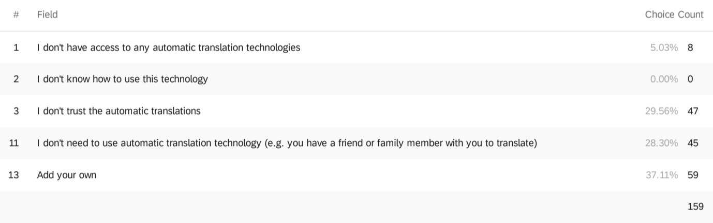

I do my own translation.

The translation isn't correct

Cannot copy and paste material into interface because it is a physical document; webcam-based translation tends to be bad

because i want to automate translation and google translate isn't very friendly to us devs.

It doesn't do correct translations

The translation is ambiguous i.e. it leads to multiple words that are different in connotation

I can read the language

Get it translated by a professional translator

I think I get the gist of the text/word by context. Emphasis on ‘think’.

Completely wrong

I don't use machine translation for long translations

the automatic tool sucks eggs, and/or fails to handle image PDFs

Look at a dictionary to learn the words

I always search for single terms and check the multiple translations for the same word. In addition is often search these multiple translations in

the dictionary to make sure the meaning conveys all the nuances I want to express

Automatic translators lack a lot of nuance. If I want a slang word it probably won't be there; if I want something specific like to know the article

in German from the german word, then an automatic translator is usually pretty useless

I have sensitive materials that I don't want Google reading / storing for all eternity

two examples: I don't need to translate something if a human translation already exists (e.g. song lyrics); Google Translate also isn't good at

displaying alternate meanings, gender, conjugations etc. like a dictionary would be (this only works for individual words)

practice how to use Chinese <--> English dictionary

I only use automatic translations for short words and phrases. For longer sentences, I try to learn the grammar and vocabulary by myself.

In addition to using translate, I will Google the phrase for context. Some transliterations lose meaning and context when only using translate

There is no answer or translation provided by Google translate

Two cases: (a) tried it and it didn't work or (b) I know enough of the target language to use a dictionary instead

The language isn't available

When the given translation is not accurate

have a friend or a relative translate the word

Automatic translations frequently omit language nuances.

If I don’t use it, it’s because I don’t have access.

Automatic translation tool does not necesseraly include cultural knowledge associated with some words

When I doubt the translation made sense

I tend to remember stuff better if I look it up in a paper dictionary

translation sometimes inaccurate or incomplete

When they don't perform well for some languages

Poor quality of automated translation

For example if I need the translation of a song I would just Google it because the translation would be more legit if that's the right word.

There are infrequent professional contexts when I require human-vetted translation

If it's a translatuon for official documentation, I'll get it professionally done

I use web searches sometimes. Or I may not have access to a translation tool at. the moment, or someone around me can translate

if text is short enough I look up the words in a dictionary

I want to _understand_ it‘s a way of learning

Sometimes it can go horribly wrong

When I know the language AND the translation effort is minimal

My own limited skills are enough

I speak the language well enough to attempt manual translation

The document is too big and we need professional translaters.

I can figure it out, no need to spend time checking

I’m trying to actually learn a new language and want to retain some knowledge

I already know the language and to the extent I'm uncertain, machine translation tools would not reduce my uncertainty.

I don't want to use it/I want to rely on my own translation

For a language that I know well, I usually want to look up a translation due to some subtlety that I know google translate can’t handle

need to login

I use a dictionary

Sometimes there is nuance or idiomatic language that I can tell needs a native speaker to translate properly

Word translations are good. Sentence translation are very poor and incorrect/

word are easy to understand

not as good, but good for a quick idea

sometimes i need a broad translation and I use automatic translation. in others i don't.

I have another option available like a book.

Automated translators are bad at slang and colloquial language, so I don't use them often for new words I come across on social media, or if I

do, not by themselves.

not applicable